

Antenatal Guidelines
&
Information on
Maternity Services in
West Herts






These antenatal guidelines were developed within a multidisciplinary working party consisting of representatives from the local PCT’s, LMC, MSLC and WHHT.

If you would like to be involved in the working party for future updates. please contact Nora Lucey Consultant Midwife WHHT

West Hertfordshire Hospitals Contact numbers 3
Pre-conception advice 4
Confirmation Of Pregnancy 5
Options Of Care and place of delivery 6
Booking 7
Criteria for consultant referral at booking 8
Criteria for Referral To Anaesthetic Antenatal Clinic 9
Criteria for Birthing Centre Midwifery led Care 9
Schedule of Antenatal care 10
Care at antenatal visits 10
Early Pregnancy Assessment 12
Bleeding in pregnancy > 13 weeks 13
ANTI-D 14
Use of anti-D prophylaxis Rhesus Negative women 15
Anaemia 16
Diabetes 17
Persistent Proteinuria in pregnancy 18
Hypertension 19
Intra-Hepatic Cholestasis Of Pregnancy 20
WOMEN WITH EPILEPSY 22
Sickle cell In Pregnancy. 23
HbA₂ thalassaemia trait in pregnant women 24
Management of Breech presentation at Term 26
Infections in Pregnancy 27
Chicken pox (Varicella) in pregnancy 28
Hepatitis B 29
Genital herpes in pregnancy 30
HIV 31
Parvovirus 32
Group B Streptococcus (GBS) in pregnancy 33
Fetal Movements 34
Consultant Antenatal clinic Timetable 35

West Hertfordshire Hospitals Contact numbers
Watford General Hospital  Ante Natal Clinic  Vicarage Road  Watford |  |  | Hemel Hempstead General Hospital  Ante Natal Clinic  Hillfield Road  Hemel Hempstead
Telephone:  Ante Natal Clinic:  Late bookers only  Early Pregnancy unit  Day Assessment Unit: | 01923 217335  01923 217339  01923 217831  01923 217851 |  | Telephone:  Ante Natal Clinic: 01442 287780  Hemel Birthing Centre:( temporarily closed dec 05)  St Albans Hospital  Ante Natal Clinic: 01727 897396
Community administration | 01923 217361
Labour Ward: | 01923 217371
Victoria Ward: | 01923 217377 |  | Genito-Urinary Medicine(GUM) Services
Katharine Ward: | 01923 217366 |  | Watford GUM clinic | 01923 217206
Alexandra Birthing Centre | 01923 217364 |  | St Albans GUM clinic | 01727 897333

Divisional Clinical Director.Consultant Obstetrician & Gynaecologist
Mr Padwick
Interim Head of Midwifery & Gynaecology
Sue Cole
01923 217937

Obstetric Anaesthetic Lead Consultant
Dr Heather Parry

Obstetric Lead
Consultant Mr F A Boret

Consultant Midwife Nora Lucey *
mobile 07766424382 01923 217502
Clinical Facilitator s*
Sue Higginbotham
Pippa nightingale *
WGH ext 7657 Bleep 1046

ABC &
Delivery suite
Matron Marina Wells
Bleep 1221

Inpatient Services
Matron Jenny Fake*
Wgh Bleep 1240
Antenatal clinics Community midwifery Matron Anne Shand *

Wgh Bleep 1243

Fetal Assessment Midwife Jill Fearnside WGH Ext 7899 aircall via WATFORD switchboard
Teenage Pregnancy Midwife* Sarah Green and Jenny Farrell 07900228028

*Supervisor of midwives
Obstetric and Paediatric Bleep Numbers via switchboard 01923 244366
Obstetric registrar labour ward Bleep 1201
Obstetric SHO labour ward Bleep 1215
Paediatric Registrar labour ward Bleep 1250
Paediatric SHO labour ward Bleep 1257

Patient Advice and Liaison Service (PALS) 01923 217198

NCT 0870 444 8707 General Enquiries

Updated May 2004

Pre-conception advice

When a woman presents herself in advance of conception with a wish to discuss a potential pregnancy, there is a window of opportunity to improve the outcome of that pregnancy.

All health care professionals approached at this time should try and establish any concerns that the potential mother may have, and in addition try and take the opportunity to discuss the following beneficial interventions.

- Folic acid 400mcg daily from 12 weeks pre-conception to 12 weeks gestation.

- Rubella serology (for those not immune - rubella vaccine if not pregnant and then wait 3 months before conceiving)

- If diabetic – tight glycaemic control and folic acid 5mg daily – early referral to the diabetic clinic

- Stop smoking

- Avoid alcohol (completely if possible)

- Try to achieve a normal weight (BMI 20 – 25 kg/m²)

- Adopt a well balanced diet and increase levels of physical activity

- If history of migraine, DVT, PET, IUGR, IUD, recurrent miscarriage – check for APLA

- If high risk ethnic group – check for haemoglobinopathies - Sickle cell and Thalassaemia – (e.g. Afro-Caribbean, Asian, Mediterranean)

- Drugs – seek specialist advice if on: -

- Anti-hypertensives
- Anti-epileptics
- Thyroid medication
- Oral hypoglycaemic agents
- Anti-depressants
- Warfarin
(Not exhaustive list)
- Check her partner’s health – drugs, alcohol, smoking, diabetes etc.

- Consider genetic counselling if previous baby has a chromosomal defect or there is a family history of such a condition.

Confirmation Of Pregnancy
Women may see their GP Community Midwife or Hospital Midwife to confirm their pregnancy and arrange their maternity care / booking.
This should occur as early in pregnancy as possible(see pge 7).

As with preconception advice attention to risk factors applying to the individual may improve the outcome of the pregnancy. Women presenting for the first time at over 20 weeks gestation are considered “Late Bookers”

At first contact :
- Confirm that +VE Home/GP/Chemist Pregnancy test has been obtained
- Arrange test if appropriate
- Confirm LMP –consider cycle length, date certainty, period normal or light, Oral contraceptive use etc
- give EDD if possible, if uncertain refer to Ante natal clinic,
- Establish current state of health
- Identify factors requiring urgent or early consultant referral (see Pge 8 criteria for consultant referral at booking)
- Discuss implications if pregnancy unplanned
ref EPU/gynae on-call if symptomatic/appropriate see page 12

At this appointment or at separate booking appointment see pages 8 & 9

- Establish if choice of preferred mode of care/Delivery site has been made offer information-choices booklet/MW/Lay contact eg NCT as required
- Complete forms-FW8 (prescription exemption) GMS2 (maternity services)
- Referral letter specify health problems which may require consultant opinion if known.
- Exam - BP Ht/WT/BMI
  - other systems if appropriate +/or symptomatic
  - Abdo/PV if late booker (as appropriate)
- Health education and Health promotion issues discussed ie: –
- Diet
- Smoking
- Alcohol/unnecessary drug avoidance
- Downs/anomaly screening- scan/Amnio
- Counsel re Booking Blood tests see below
- –check if taking Folic Acid at correct dose –offer Rx if not
(400mcg/day but 5mg/day if on anticonvulsants or PH /1stdegree FH NTD)
- Calcium +Vit D –offer to Asian/Vegan women

This information should be considered together with referral criteria pages 7,8 & 9

Options Of Care and place of delivery

For most women it is suggested that Shared care (community midwife and GP) should be the routine booking system. Women wishing to book at the birthing centres for delivery can book through their community midwife or direct with the centres.

Consultant care should be offered to those who are not “low-risk”, or at special request .

The DOMINO care. (Women in early labour can be assessed at home, then transferred with the community midwife to the maternity unit)
Women who choose this option should arrange this with their community midwife, only a limited number of such cases can be supported because of the other demands on midwife time.

Pregnancy confirmed <20weeks
self or GP referral for booking by CMW or
to consultant for booking see booking criteria
Shared care with GP and Community midwife
Low risk pregnancy
Consultant care choice or high risk pregnancy
home

Birthing centres
Delivery suite WGH
Out of area hospital

Domino care option by CMW

For all late bookers >20 weeks refer directly to hospital for urgent booking appointment on direct line 01923 217339 note: no other queries will be dealt with via this number

Booking

Women are booked in the community, the midwives’ antenatal clinic at the surgery, or hospital antenatal clinic, or at home.
Information obtained from the history taking generally includes:

Medical history.
Surgical history.
Obstetric history.
Social history e.g. domestic violence, child protection issues, illicit drug usage if known
Relevant family history, eg hypertension, hereditary conditions, TB contacts, twins, congenital abnormalities, first degree relative with diabetes.
Menstrual history.
LMP – EDD, gestation at time of history and date of fetal movements, if relevant.
Date of last smear test.
STD.
Counsel re HIV routine testing.
Current medication.

Health education and Health promotion issues discussed ie: –
- Diet
- Smoking
- Alcohol/unnecessary drug avoidance
- Downs/anomaly screening- scan/Amnio
- Counsel re Booking Blood tests see below
- –check if taking Folic Acid at correct dose –offer Rx if not
(400mcg/day but 5mg/day if on anticonvulsants or PH /1stdegree FH NTD)
- Calcium +Vit D –offer to Asian/Vegan women

This information should be considered together with referral criteria pages 8 & 9

Routine Booking Blood Tests for all women

- FBC, blood group and antibodies.
- Rubella, syphilis and hepatitis B.
- Random blood sugar
- Haemoglobin Electrophoresis
- HIV following counselling

Please use the hospital number and / or date of birth on the form.
Please write: ‘antenatal booking blood’ on the form.

Criteria for consultant referral at booking
* Updated May 2004
**Updated Jan 2006

Women with medical conditions which might complicate pregnancy or labour or affect the infant, eg
- Diabetes,
- HIV,
- Hepatitis B,
- Hypertension,
- Cardiac or renal disease,
- Thyroid disease
- Epilepsy,
- SLE
- Haemoglobinopathy. see page 22
- Previous deep vein thrombosis, or Pulmonary embolism,
- Coagulopathy or Any women on Anticoagulation Therapy
- Mental illness- eg depression currently on medication, Schizophrenia
- Women refusing Blood products**
Past surgical History
- Anaesthetic problems see page 5
- Fractured Pelvis
- Blood transfusions

Social history e.g. domestic violence, child protection issues, illicit drug usage
All late bookers 20 weeks plus, have an initial midwifery booking then should be referred for consultant booking. If unsure whether referral is appropriate the consultants are happy to discuss these cases by telephone: please contact the appropriate secretary or the oncall registrar.
This does not include late transfers from other units with normal obstetric history.

Gynaecological History
- Previous infertility
- pelvic floor repair
- myomectomy or any uterine surgery
- uterine abnormality
- Genital infections (STD)

Family History
- Congenital anomalies
- Diabetes
- High Blood Pressure
- Depression / Mental Illness
- Blood or clotting problems

Previous obstetric history
- Low Birth Weight Baby <2500kg
- High Birth Weight Baby >4.5kg *
- Grand Multiparity >5
- Proven Cephalopelvic Disproportion
- Previous Caesarean Section
- Major Post Partum Haemorrage requiring transfusion or > 1000mls
- Rhesus Or Other Antibodies
- Eclampsia/HELLP*
- Difficult Or Rotational Forceps
- Third/Fourth Degree Tear
- IUD, Stillbirth Or Neonatal Death
- Anti phospholipid antibodies
- Recurrent miscarriage ( 3 or more*)
- Fetal Abnormality

Criteria for Referral To Anaesthetic Antenatal Clinic

Any history anaesthetic problem
Family history of anaesthetic problem
Allergy to anaesthetic drugs (scoline apnoea)
Difficult intubation
Ischaemic heart disease
Cardiomyopathy
Valvular heart disease
Congenital heart disease
Any history of intracranial bleeding or surgery
Myasthenia gravis
Any surgery for back problem
Scoliosis or any surgery for scoliosis
History of bleeding
Anti coagulant therapy

BMI >40 at booking *** 2008 reviewing

However if you have any doubt discuss with the on call anaesthetist through main switchboard on Bleep1122 before referral to the clinic.

The anaesthetic antenatal clinic is booked through the fetal day assessment unit on 01923 217851

Criteria for Birthing Centre Midwifery led Care

Women may self refer direct to the birthing centres or be referred via their community midwife.

- Women with no medical conditions or antenatal complications
- Age 18-40
- Women having their 1st –5th baby *** (Nice 07)
- Pregnancy of 37 weeks to 40 weeks + 12 days gestation or until agreed induction date
- Singleton with cephalic presentation
- Previous uncomplicated obstetric history or where a recurrence of a complication is not anticipated
- Women with BMI of 18-35

If a woman is referred to the obstetric team in the antenatal period, the doctor should document if the woman is still suitable for Midwife Led Care in the Birth Centre. If uncertain the Consultant Midwife should be contacted for advice.
Woman who do not meet the above criteria may be referred to the consultant midwife for a birth planning appointment where cases can be considered on an individual basis.
Updated May 2004 reviewing 2008

Schedule of Antenatal care
- 8 - 12 weeks booking and blood tests (FW 8 form signed)
- 15-16 weeks hospital appointment for Serum screening optional
- 18-20 weeks hospital appointment for anomaly ultrasound optional
- 24/25 weeks antenatal check- confirm EDD with USS dates no change in dates if + or – 10 days difference (Mat B1 form issued from 20 weeks)
- 28 weeks antenatal check and Full blood count, Random blood sugar and antibodies (Rh neg -Anti D)
- 31/32 weeks antenatal check
- 34-36 weeks antenatal check and Rh neg - Anti D.
- appointment for USS for placental site if previously low lying placenta.
- 38 weeks antenatal check

The Midwife during the 40-41 week Antenatal check if still low risk criteria books an induction of labour for post maturity at 40 weeks +12 days, this is booked with Delivery Suite and Victoria Ward .

A Membrane Sweep should be offered.

An appointment for 40 weeks +10 should also be booked at the Fetal Day Assessment unit (WGH) or the Maternal Day Assessment unit (HHGH) for an Electronic Fetal Heart rate monitoring (EFM).
- 40 weeks antenatal check

- 41 weeks antenatal check

2008 review

Care at antenatal visits
- Blood pressure and urinalysis
- Abdominal palpation
- Auscultation of fetal heart from 16 weeks
- Fundal height measurement from 20 weeks
- Parenthood education arranged through community midwife
All measurements and observations must be documented on the woman's antenatal hand held notes.

Schedule of Antenatal care :- Updated May 2004

NICE 2003 National Institute for Clinical Excellence Antenatal Care: Routine Care for the healthy pregnant woman.
Referral at booking or during Antenatal care
- Maternal age <16 years and > 37years at delivery
- Women with BMI of <18 >35*
- Hyperemesis gravidarum
- Anaemia (HB 8.0 g/l or below or MCV <80) page 16
- Random Blood glucose Above 7.0g/L page 17
- Persistent Proteinuria >+1 page 16
- Hypertension (BP over 140/90) with or without proteinuria page 17
- Maternal Jaundice and / or Puritus in Pregnancy
- Any women on Anticoagulation Therapy
- Presence of Atypical Red cell or auto antibodies
- Infections in pregnancy pages 24-30
- Fundal height Large or Small for gestational age
- Vaginal bleeding after second trimester
} Same day referral to delivery suite
- Suspected preterm labour
- Preterm pre-labour rupture of membranes
- Pre-labour rupture of membranes <37 weeks
- 12 days post EDD
- Multiple pregnancy
- Suspected Malpresentation or Breech presentation > 36 weeks see page 26
- Reduced Fetal movements after 28 weeks(< 10 movements in 9 hours) see page 34
- Unstable lie from 37 weeks

For non urgent referrals please contact hospital antenatal clinic for an appointment with appropriate consultant team. Alternatively referral to either day assessment units. For urgent referrals please contact oncall obstetric registrar via switchboard 01923 244366 bleep 1201 or delivery suite direct 01923 217371 / 217920

Criteria under review 2008

Early Pregnancy Assessment

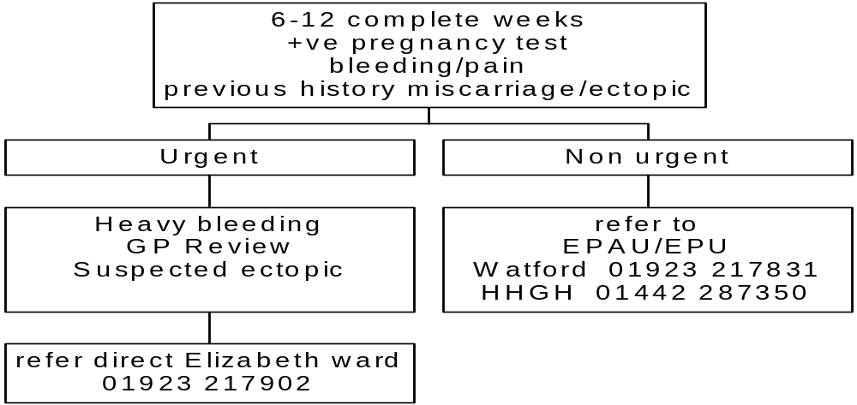

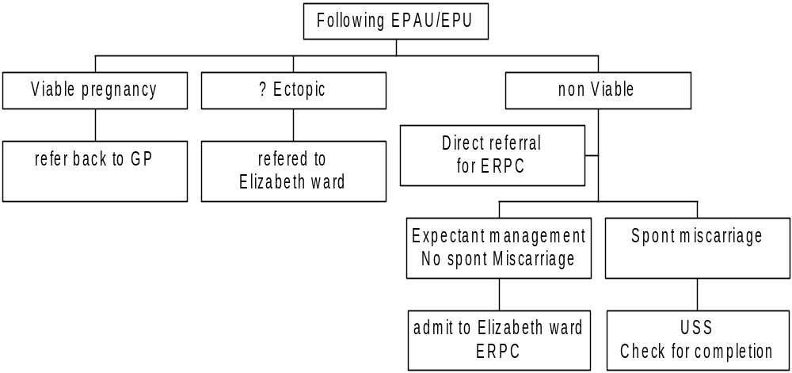
* Please note that if client is under 6 weeks pregnant or when unsure of LMP BhCG level must be obtained. This level must be at least 1500 IU/L before the patient can be referred to Early Pregnancy Unit for ultrasound scan.

The Miscarriage Association (Registered Charity No 1076829). c/o Clayton Hospital, Northgate, Wakefield, West Yorkshire, WF1 3JS. Telephone 01924 200799.

Bleeding in pregnancy > 13 weeks

Bleeding in pregnancy

> 13 weeks

>13 weeks-18 weeks
> 18 weeks-23 completed weeks
>24 weeks

With or without pain

Contact Gynae SHO
01923 244366 bleep on call SHO

With or with out pain

Contact Gynae SHO
01923 244366 bleep on call SHO

Contact Obstetric Registrar
01923 244366
bleep 1201
and notify Delivery suite

Admit directly to Elizabeth ward
01923 2171902
Case by case decision by registrar on place of referral or admission
Admit directly to Delivery suite
01923 217371

EPUA hours: Watford Antenatal Clinic, Ground Floor, Maternity Unit

Monday – Thursday 08.30 – 16.00 (Fridays from May 2003)
Scan Appointments (at 30-minute intervals): Monday – Thursday 08.30 – 13.00
Midwife Practitioner/ Sonographer - Jenny Webb, Catherine Rycroft, Tracy Hearsey EPU Co-ordinator - Susan Kerin

Out of clinic hours or when the clinic is unattended a message should be left on the voice mail and any referrals or messages will be dealt with as soon as possible.
Any urgent referrals on Friday's or weekend's/ night time should be directed to Elizabeth ward at Watford.

EPU (Scanning) Hemel Hempstead Ultrasound Department Verulam wing

Monday - Friday, 09.00-10.15
EPU Sonographer clinic Appointment number
Gynaecology Liaison Nurse Debbie Sutton

Out of clinic hours or when the clinic is unattended a message should be left on the voice mail and any referrals or messages will be dealt with as soon as possible.

Appointments can be arranged for WGH and HHGH by telephoning 01923 217831

ANTI-D
Anti-D is to be given to all pregnant rhesus D negative women without pre-existing anti-D following the potential sensitising events:
- All miscarriages (spontaneous and therapeutic) after twelve weeks gestation.
- All miscarriages, irrespective of period of gestation, where surgical treatment is undertaken.
- Threatened miscarriage, where bleeding continues after twelve weeks gestation.
- Following Amniocentesis, ECV or any procedure likely to cause fetomaternal haemorrhage

If clients are admitted to Elizabeth Ward, it is the ward staff who are responsible for ascertaining the rhesus status, administering anti-D, and explaining to the client the reasons for administration.
If the client’s rhesus state is ascertained by the Early Pregnancy Clinic (after blood samples have been taken and sent to the Blood Transfusion Department) the midwife/nurse practitioner will administer the anti-D and refer the client to the Fetal Day Assessment Unit for further anti-D later in pregnancy.

Use of anti-D prophylaxis Rhesus Negative women

Immunoprophylaxis using anti-D Immunoglobulin has resulted in a reduction of deaths attributed to RhD auto immunisation from 46/100,000 births to 1.6 /100,000. (RCOG 2002) Seventeen percent of all births in the UK are to Rhesus negative women. Of these babies about 59% are rhesus positive. (NICE 2002) The following guidelines have been adapted from the Royal College of Obstetricians (RCOG 2002) and the NICE guidelines.(NICE 2002)

- All Rhesus negative women will be given the Patient information leaflet produced by NICE or suitable alternative at booking or before 28 weeks.
- Women who are rhesus negative will be offered routine antenatal anti-D prophylaxis (RAADP) at 28 weeks and 34 weeks gestation.
- Via MDAU at HHGH or FDAU at WGH
Discussions should include the circumstances where RAADP would be not recommended, such as where the woman:
- Has opted to be sterilised after the birth of the baby
- Is in a stable relationship with the father of the child and the father is known or found to be RhD-negative
- Is certain that she will not have another child after her current pregnancy” (NICE 2002)
NB “However, it may be difficult for the woman to be certain about these factors. In individual cases these issues should be discussed between the clinician responsible for prenatal care and the pregnant woman and they should also form part of the general information regarding the relative risks and benefits of RAADP” (NICE 2002)
- Test for red cell antibodies will be performed prior to routine administration of anti D at 28 weeks
- Further testing for anti-D antibodies prior to delivery is not recommended.
- Staff administering anti-D must ensure the woman is aware that anti D is a blood product
- Women should be informed of the difference between routine prophylaxis and prophylactic anti D given because of likely sensitisation

- Women who are exposed to the possibility of a sensitising event should be offered Anti-D within 72 hours see page 14
- For all events after 20 weeks requiring Anti D 1250 iu is given followed by a Kleihauer test to identify fetomaternal haemorrhage (FMH). Additional Anti-D will be given as required.

Anti D administration is available through the fetal day assessment unit at Watford and the maternal day assessment unit at Hemel.

NB A woman's use of RAADP at 28 and 34 weeks should not be affected by whether she has already had antenatal anti-D prophylaxis (AADP) for a potentially sensitising event early in pregnancy.Bleeding in pregnancy > 13 weeks

Anaemia

Booking or at any stage in pregnancy

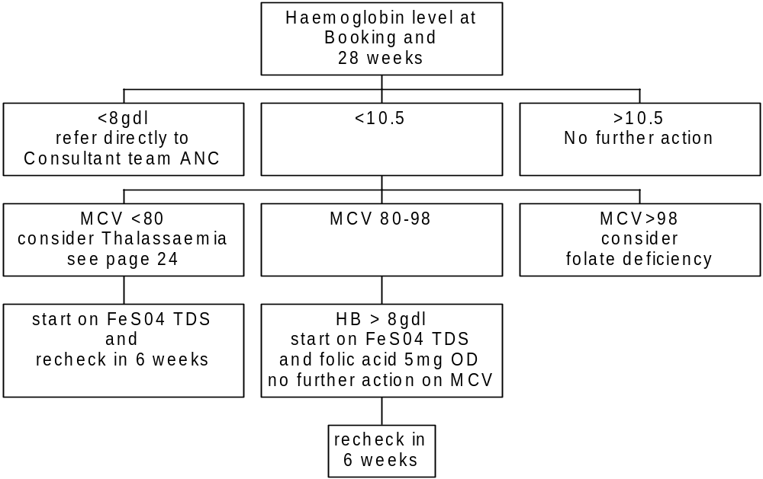

NB

- Iron therapy is not recommended before 15 weeks gestation.

- Women whose anaemia is not responding to treatment, particularly if late in pregnancy or Hb =or <8 g/dl, should be referred to the antenatal clinic.

Diabetes

All known diabetic women will be booked under hospital consultant care, they require hospital booking appointments as early as possible and referral to combined obstetric and endocrine clinic's. It is essential that prior to pregnancy optimal glucose control is achieved and women are started on folic acid 5mg daily.

Screening for Gestational Diabetes and Glycosuria In Pregnancy

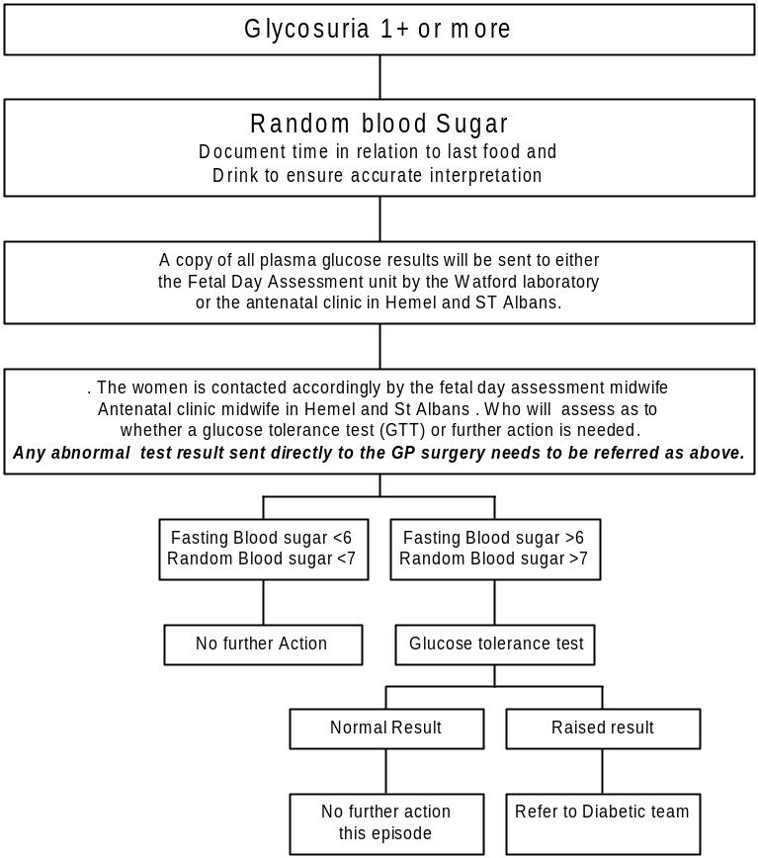

Urine should be tested for Glycosuria at each antenatal visit for all women.

Whenever it is detected then a plasma glucose sample should be taken and the time recorded, however many times this happens.

Updated Jan 2006

Persistent Proteinuria in pregnancy

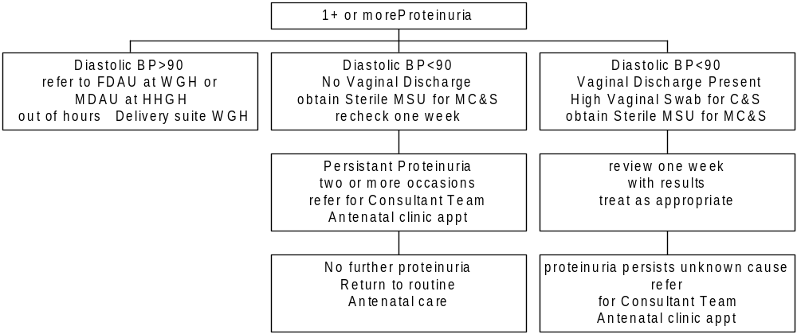
See page 19

Hypertension

Women with known Hypertensive disease or renal disease refer to Mr Sheridan for review in Monthly combined medical clinic at WGH, and Mr Sanusi on HHGH and SACH site.

If BMI >35 use large cuff.

At booking: BP > 140/90 mmHG. Refer to Hospital for Consultant booking

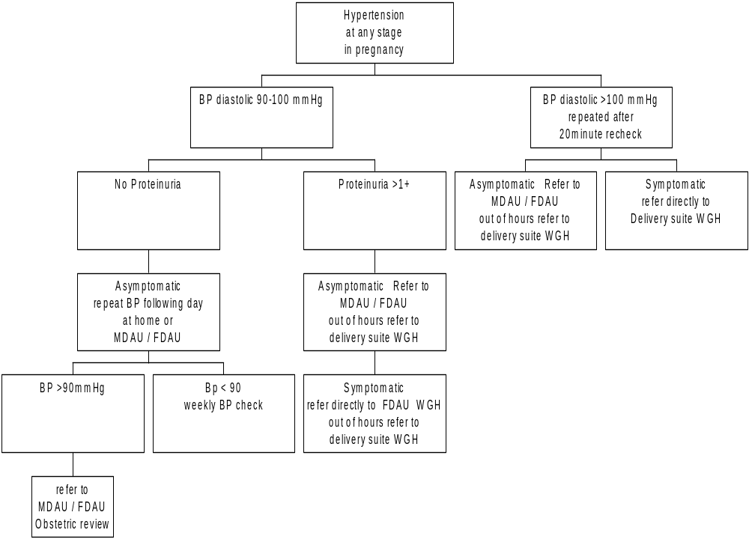

Maternal Day Assessment Unit HHGH: 01442 287493
Fetal Day Assessment Unit WGH: 01923 217851
Delivery Suite direct line WGH: 01923 217371 / 217920

Intra-Hepatic Cholestasis Of Pregnancy

Information: Idiopathic condition related to pregnancy and characterised by Cholestasis. Can be associated with adverse outcomes for a mother and baby. With a < 5% Mortality risk to baby.

Typically symptoms commence from 28 weeks onwards, although extremely rare may occur in first trimester.

Main symptoms:- Generalised pruritus Jaundice not usual but follows in some cases. There may be darkening of urine and lightening of stools with occasional upper GI symptoms – nausea, and right upper Quadrant pain.

Suspicion should be raised with Generalised pruritus, pronounced especially in the palms and soles and without dermatological disease (skin rashes) in the third trimester.

However note there may be excoriation from scratching. Pruritus if confined to the abdomen is common and not typical of IHCP.

Biochemically, typically ↑↑ Bile acids
↑↑ Alk phosphates

Mild to moderately elevated bilirubin and liver enzymes.
Also important to check Hepatitis, serology and in some cases auto antibody screen (antimitochondrial antibodies) for primary biliary cirrhosis and ultrasound of liver and gall bladder.

Risks of IHCP
- ↑ Obstetric haemorrhage
- ↑Preterm labour
- ↑ Stillbirth

Management

Pre-pregnancy
- ↑recurrence rate, therefore in subsequent pregnancies patient needs pre conceptual counselling about possible recurrence (about 70%). Early consultant referral in future pregnancies.
- Consider ultrasound liver/gall bladder to exclude gall stones, other liver disease.

Ante Natal

Suspicion of IHCP → check LFT’s and refer to hospital(Ante Natal Clinic). note raised Alkaline Phosphate physiological in pregnancy. If LFT’s abnormal refer to next hospital antenatal clinic.

If clinically jaundiced refer the same day directly to delivery suite.

Main principles of Hospital Management

(i) Control of Maternal Symptoms/Priorities.

Options:-

- Ursodeoxycholic acid
- Antihistamines
- Cholestyramine (few indications for use)
- Phenol 1% + 1- menthol in aqueous cream
- (Future possibility – Dexomethasone)

(ii) Monitoring of Fetal Wellbeing.

- Serial cardiotography
- Serial ultrasound assessment of fetal growth and biophysical profile.
- Doppler assessment of fetal umbilical artery blood flow

(iii) Vitamin K Supplements from Around 36/40 gestation.

(iv) Determination of Timing and mode of delivery is usually around 38/40.

WOMEN WITH EPILEPSY

- Women on Anti Epileptic Drugs (AEDs) should already be aware, prior to pregnancy, that there is a risk of fetal abnormality associated with taking some AEDs; particularly sodium valproate, phenobarbitone, phenytoin and carbamazepine. The risk is of the order of 2-6%, but may be higher with multiple drug regimes. The risk with the newer AEDs are not yet clearly established.

- folic acid 5mg daily should be started on 2-3 months prior to conception and throughout pregnancy.

- All women are referred for early booking in consultant clinic.

- The ultrasonographer should be made aware of the drug history when the patient attends for anomaly scan.

- Compliance with medication during pregnancy should be emphasised, as seizures, particularly tonic/clonic, represent a risk to the fetus. Abruptly stopping AEDs increases the risk of seizures and is a well recognised precipitant for status epilepticus.

- Current anticonvulsant should be accurately documented including dosage.

- Seizure frequency during pregnancy should be noted. Previous pre-pregnancy frequency of seizures should also be known. Seizure frequency may change during pregnancy.

- AED levels (phenytoin / carbamazepine / phenobarbitone) may be useful if seizure control is poor. A base-line level in the first trimester is helpful, as is a level taken during each trimester. AED dosages may need to be increased.

- Multidisciplinary antenatal care involving the neurology team is usually undertaken

- Vitamin K oral 10mgs daily from 36 weeks is administered.

- Enter patient onto epilepsy in pregnancy register

Patients should be encouraged to take their maternity notes to their Neurology Clinic appointments, if they are currently attending.

Sickle cell In Pregnancy.

Relates to all women with homozygous sickle cell disease HbSS; HbSC; HbS/B Thal and other variants with a history of sickling.

Commonly found among West African and Afro-Carribean ethnic groups, though women from other ethnic groups can be affected (much less common).
Sickle cell is characterised by severe anaemia (Hb 6-9g/dl) and frequent painful crises. In sickle crises, the RBC form a sickle shape and block small vessels, leading to tissue infarction, commonly affecting the kidneys, spleen, joints, femoral head, lungs, retina.
Renal complications are very common (almost constant), where there is a progressive inability to concentrate urine. Proteinuria, haematuria and potassium secreting defects are commonly seen.
Note: As a result, pregnant sickle cell women are more prone to dehydration in labour and as such, more at risk of a sickling crisis.
These women are also more prone to thrombo-embolic events.
Other potential complications include acute chest syndrome, CVA, retinopathy, aseptic necrosis of the femoral head and vertebrae.

Principles of Antenatal Management

- Pregnancy planning preconception folic acid 5mg BD
- Early booking appointment with consultant team
- Full Consultant care with multi-disciplinary hospital team comprising of :-

Mr F A Boret Consultant Obstetrician.
Dr A Wood Consultant Haematologist.
Dr H Parry Consultant Anaesthetist.
Jill Fearnside Fetal Assessment Midwife

- Adequate patient counselling. Offer partner testing and prenatal diagnosis if indicated.
- FBC/Ferritin/MSU monthly; U&E’s/LFT alternate months.
- Examine patient heart, lungs, liver, spleen, hip/joint mobility, check for jaundice (sclera)
- Serial fetal growth USS – 2-3 weekly.
- Folic acid 5mg b.d. throughout pregnancy.
- If patient already on prophylactic antibiotics(Penicillin V), continue.
- LMWH (Clexane) from 32 weeks gestation and continue till six weeks post partum.
- Do not give iron supplements.
- Low threshold for admission. Inform Haematology team.
- Aggressive treatment of any infection
- Decisions on transfusions to be made by Consultant Haematologist except in acute emergencies, eg. following a significant APH/PPH.

HbA₂ thalassaemia trait in pregnant women
Flow chart demonstration procedure for diagnosis of α and normal
HbA₂ thalassaemia trait in pregnant women (patients) and their partners.

Normal HbA₂, MCH <26pg and normal serum ferritin * (4)

IS ETHNIC ORIGIN AVAILABLE?

YES

NO
SCREEN PARTNER

If patient is If patient is: If patient is:
Northern European, Chinese Mediterranean(e.g.Cyprus,Greece)
African or SE Asian Saudi Arabian
Afro-Caribbean Hong Kong South Asian
South China
Malaysia

STOP
Thailand
Philippines
Vietnam
Singapore
Greek
Turkish
Cypriot
SCREEN PARTNER
SCREEN PARTNER

If MCH <25pg and If normal If normal If ⬆ HbA₂ If low MCH normal HbA₂ also one of + consanguineous
the above ethnic groups
DNA analysis on both patient and partner to exclude α° thal
STOP
DNA analysis on both patient and partner

* (6 and 7)
Normal HbA₂ and ⬇ serum ferritin and MCH <23
or MCV <73 or RBC >4.8 x 10⁹/l

West Hertfordshire Hospitals NHS Trust
Author: Dr Anna Wood, Consultant Haematologist
April 2003

SCREEN PARTNER

Cross references to page 25

Partners screening should be requested of following via hospital ANC:

- All women with haemoglobin variants
- All women with Beta Thalassaemia trait or Delta/Beta Thalassaemia trait
- All women with Hereditary Persistence of Foetal Haemoglobin (HPFH)
- All women with putative Alpha Thalassaemia trait ( MCH<26pg, normal HBA2 and normal serum ferritin)
- All women with borderline HbA2 levels ( >3.6).
- All women with iron deficiency and RBCs > 4.8 x 109/l.
- All women with iron deficiency and MCV <73 or MCH <23

Management of Breech presentation at Term

Breech suspected at >36 weeks
ECV successful

ECV unsuccessful
ANC one week to check presentation then return to Shared care

Opted for ECV
Declined ECV

Refer to next Consultant team ANC - Breech confirmed
Counselled re delivery options Offer ECV

Appointment for next ECV Consultant Clinic book with main delivery suite
Starved for 4 hours prior to appointment, admit directly to delivery suite
Elective Caesarean section booked for 39 weeks

Patient refuses or is uncertain re elective Caesarean Section
Book Consultant clinic appointment ASAP
Grade A Recommendation Royal College of Obstetrics and Gynaecology
External Cephalic Version (ECV) turning the baby from a breech presentation to a cephalic presentation.

Infections in Pregnancy

Rubella

All pregnant women with suspected rubella or exposed to rubella must be investigated serologically, irrespective of a history of immunisation, clinical rubella or a previous positive rubella antibody result.
Close collaboration between microbiologists and clinicians is essential for the accurate interpretation of serological results. Further specimens may be needed.

Rubella screen at booking
Establish Immune Status
Positive

Immune
Negative

Non immune
6 Weeks postnatal appt offer immunisation
Rubella contact
confirmed / suspected

Immune or non immune
<20 weeks gestation and non immune or Igm present
refer to next consultant clinic
Inform the CCDC

Blood sample as soon as possible after exposure record LMP and 1st and last contact date of exposure on blood form

Close collaboration between microbiologists and clinicians is essential for the accurate interpretation of serological results. Further specimens may be needed.

Chicken pox (Varicella) in pregnancy

(From Green Top Guidelines RCOG)

Pregnancy:
Varicella non-immune
avoid contact with varicella

immune no problems

Contact with Varicella in Pregnancy

Blood for V2IgG as soon as possible after exposure.

Non-immune

Give V2I g4 as soon as possible and < 10 days from contact available: counsel re: vaccine by G.P. post natally.
Immune

No problems

Varicella Contracted in Pregnancy

- 20 weeks
1-2% chance of fetal varicella syndrome

refer for detailed
US scan 16-20 weeks or 5 weeks post infection.
ophthalmological exam of newborn.

> 20 weeks
Within 24hrs and 48 hrs of rash first appearing give oral aciclovir.
800mg x 5/day for 7 days with informed consent for treatment.
no evidence of harm to fetus.
ADM IT to Watford on to medical care ward.
with any:
chest symptoms
neurological symptoms
haemological
rash bleeding
imumosuppression. other risk factors
smoking
chronic lung disease
steroids

Physicians to inform obstetric team
on call.

5 days before and upto2 days after delivery.
Aciclovir to mother
V2IG to baby
Aciclovir to baby if varicella acquired.

Hepatitis B

All women at booking will be offered hepatitis B screening as part of their booking bloods. (This is an opt out system rather than an opt in).

If testing is negative the process ends here.
If testing is positive, microbiology will contact the fetal assessment midwife at Watford, ANC at HHGH and SACH who will arrange an appointment with the woman to explain the results, give information leaflets and repeat bloods including LFT's and Hepatitis B markers.

The midwife also informs:
- consultant obstetrician
- community midwife
- GP who then informs Health visitor attached to surgery

The Midwife/Consultant team refers the woman to:
- GUM clinic
- Mr Bruce Macfarlane Consultant Gastroenterologist
- Dr Quist -Therson Paediatrician
- Dr Hislop Community paediatrican
- Core Midwife delivery suite

Positive – the baby will require immunisation against Hepatitis B. If the mother is a “high risk” positive, the baby will require specific Hepatitis B immunoglobulin in addition to immunisation.

The fetal assessment midwife arranges for vaccine and or Immunoglobulin to be placed in fridge on delivery suite at WGH for the neonate post delivery. The vaccine must be given within 24 hours of delivery by the paediatrician

The midwife responsible for the delivery informs
- Dr Quist -Therson Paediatrician
- Dr Hislop Community paediatrican
- GP/Health visitor

Genital herpes in pregnancy

The risks are greatest when a woman acquires a new infection (primary genital herpes) during late pregnancy, so that the baby is delivered before the development of protective maternal antibodies

Any woman with suspected first-episode genital herpes should be referred to a genitourinary physician, who will advise on management and arrange a screen for other sexually transmitted infections. Treatment with aciclovir should be considered for all women who develop a first episode of genital herpes in pregnancy.

Neonatal herpes is a severe systemic viral infection with a high morbidity and mortality, which is most commonly acquired at or near the time of delivery. Almost all cases of neonatal herpes occur as a result of direct contact with infected maternal secretions, although cases of postnatal transmission have been described.

Suspected Genital Herpes

Urgent Appointment with local
Genito Urinary Medicine (GUM) clinic

< 34 weeks

> 34 weeks
Refer to Consultant Team Antenatal clinic

Refer to next Consultant Team Antenatal clinic
Daily suppressive aciclovir in the last four weeks of pregnancy may prevent genital herpes recurrences at term
(Grade A RCOG)

Recurrent episode or First episode in first or second trimester
Daily suppressive aciclovir in the last four weeks of pregnancy may prevent genital herpes recurrences at term
(Grade A RCOG)

First episode of genital herpes within 6 weeks of EDD

Elective caesarean section may be considered at term, or as indicated, and the paediatricians should be informed.
(Grade B RCOG)
Not sole indicator for Elective caesarean section,
(Grade B RCOG)

HIV

Antenatal screening

- An HIV test will be offered to all women at booking as part of routine antenatal screening.

- At booking interview with the midwife the woman will be given information pertaining to all antenatal blood tests, including HIV.

- The HIV test as with all other screening tests, is an opt out test.

- Women will be informed that if there is any problem with any of their antenatal blood tests then they would be contacted directly by the antenatal clinic for further discussion with the HIV nurse specialist, Community midwife and Fetal assessment midwife and a subsequent appointment with Mr Boret (Obstetric lead – HIV WGH ) or Mr Sanusi (HHGH)

- The antenatal clinic will receive HIV results once a week. The named co-ordinator (clinic manager or her named deputy) will check the results. GP's will not receive any HIV results directly from the laboratory. The GP will only be informed if the woman gives her consent.

- Positive results will only be written in the hand held notes with the woman's consent. Positive results will be filed on the hospital tracer card.

- HIV negative results will be placed in the hand held notes

Mode of delivery

There is now good evidence that the risk of transmitting the HIV virus from mother to baby can be considerably reduced by delivering the baby by caesarean section, treatment with zidovudine and avoiding breastfeeding.
Ref: Steer P, BMJ 311 1209-1211 (1996).

Parvovirus

Slapped cheek syndrome (Erythema infectiosum)

Infection risks
Spontaneous abortion <20 weeks 14.8%
>20 weeks 2.3%
Hydrops <20 weeks 14.8%
>20 weeks 2.3%

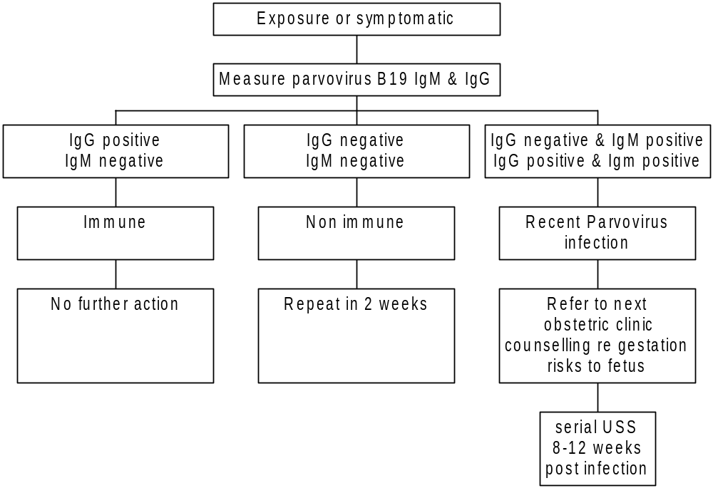

Group B Streptococcus (GBS) in pregnancy

Women identified as at risk

Women found to be Group B streptococcus in pregnancy at any time

i.e., urine, perineal, or low/high vaginal swabs
must have this documented in their hand held notes when identified

- Pre-term labour or membrane rupture (<37 weeks)
- Rupture of membranes (24 hours before delivery)
- Maternal pyrexia during labour
- Two or more of the above risk factors
- Previous baby developed GBS

Women with a positive swab result in a previous pregnancy (but an unaffected infant) should be screened at 36 weeks with a perineal swab, and if this swab is negative with no other risk factors present, no treatment is required.

Management of women identified as at risk

Women are advised to present themselves early in labour to the delivery suite to have antibiotic cover for labour.

Updated Jan 2006

Fetal Movements

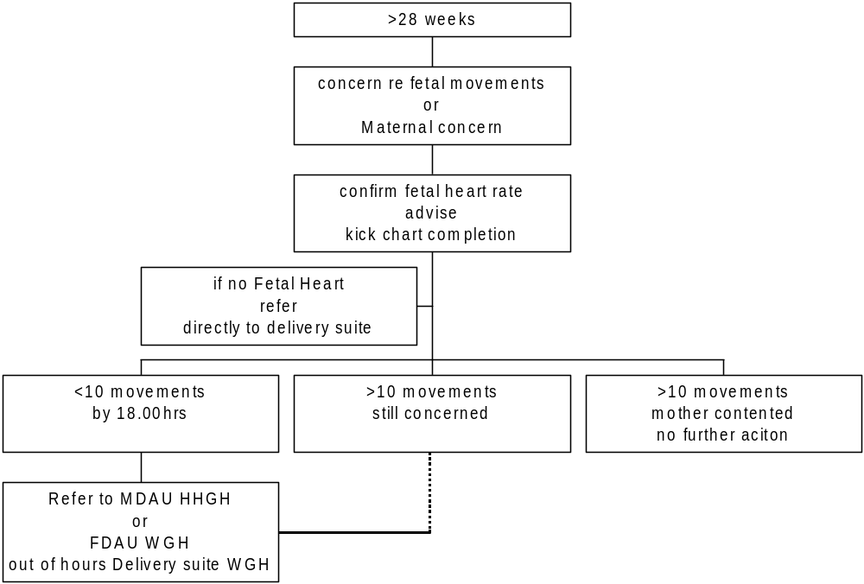
Kick chart in handheld notes

Consultant Antenatal clinic Timetable

Mr F A Boret Consultant Obstetrician and Gynaecologist
Wednesday AM Booking & Antenatal Follow Up's ANC WGH
Wednesday PM Antenatal scanning clinic ANC WGH
Friday AM Combined Diabetic Clinic monthly ANC WGH

Mr D R Griffin Consultant Obstetrician and Gynaecologist
Tuesday AM Booking ANC WGH
Tuesday PM Antenatal Follow Up's ANC WGH
Thursday AM Antenatal scanning clinic ANC WGH

Mr A Hextall Consultant Obstetrician and Gynaecologist
Wednesday PM Booking & Antenatal Follow Up
HHGH & SACH Alternate weeks

Mr L M Irvine Consultant Obstetrician and Gynaecologist
Tuesday AM Booking Antenatal Follow Up ANC WGH

Miss M Coker Consultant Obstetrician and Gynaecologist
Thursday AM Booking & Antenatal Follow Up
HHGH & SACH Alternate weeks

Mr Sanusi Consultant Obstetrician and Gynaecologist
Monday PM Antenatal scanning clinic ANC
SACH Alternate weeks
Tuesday PM Booking & Antenatal Follow Up
HHGH & SACH Alternate weeks
Tuesday AM Combined Diabetic Clinic ANC
SACH Alternate weeks

Mr R J Sheridan Consultant Obstetrician and Gynaecologist
Tuesday AM Antenatal scanning clinic ANC WGH
Wednesday PM Booking & Antenatal Follow Up ANC WGH
3rd Wednesday in month pm Combined medical ANC
Friday AM Combined Diabetic Clinic monthly ANC WGH

Mr Tayob Consultant Obstetrician and Gynaecologist
Tuesday PM Booking & Antenatal Follow Up's
HHGH & SACH Alternate weeks

Consultant Antenatal clinic Timetable:- updated February 2004

NICE 2003 National Institute for Clinical Excellence Antenatal Care: Routine Care for the healthy pregnant woman.
NICE 2003 National Institute for Clinical Excellence Antenatal Care: Routine Care for the healthy pregnant woman.

